Creating virtual machine

**Task:   To create VM in an Availability set and Creating disk and spinning up new VM using snapshot of the disk and Creating New VM using sysprep by the image**

Create resource group

Created VNET : Pkvnet

Creating virtual machine

Create snapshot prashi

Created managed disk pkqr-disk

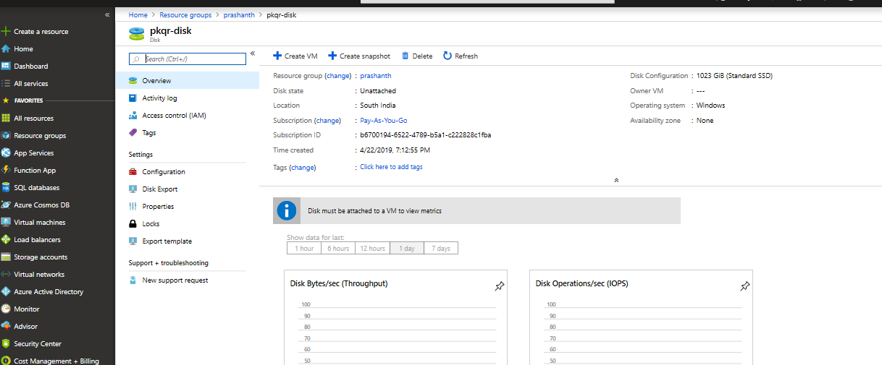

Connected to RDP

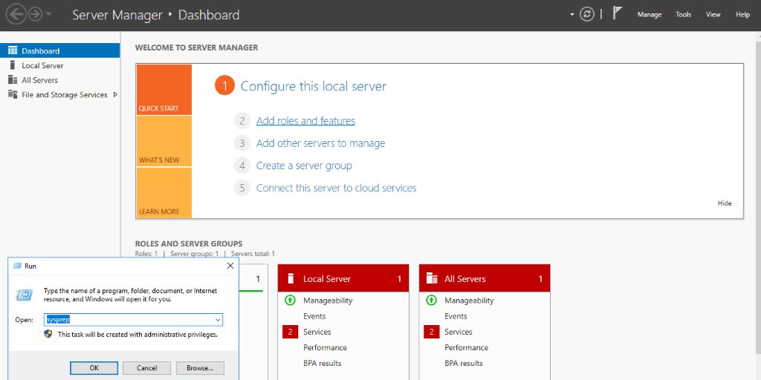

Enabling Sysprep

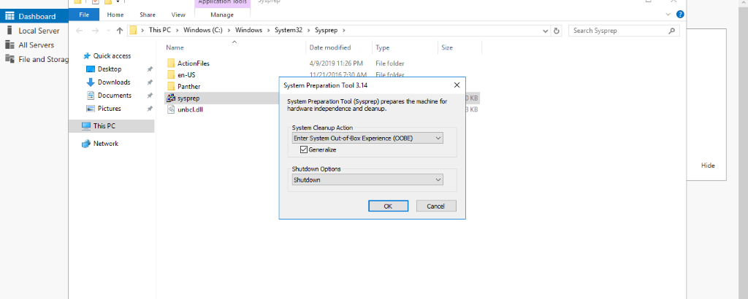

Creating  another VM using Image

